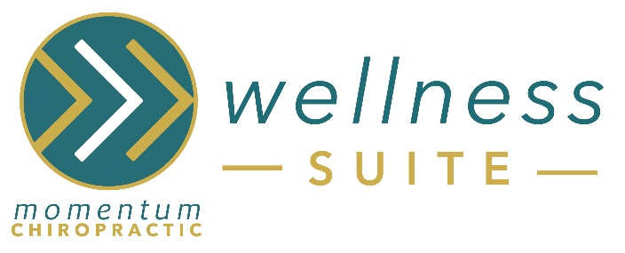
Welcome to Zerobody Dry Floating!
How to Prepare for your Session:
- Arrive odor free - no perfumes, lotions, smoke, or fragrance producing products
- Wear comfortable clothing
- Remove shoes, all jewelry, and ALL objects from pockets
- No food/drinks or electronic use permitted in the dry floating room
- Read instruction poster in the room prior to starting session
- Relax & Enjoy!

What to Expect During/After your Session:
Keep in mind that possible effects of Dry Floating may include:
- Deep relaxation
- Stimulates blood flow
- Reduces stress levels
- Releases natural endorphins

Recommended Frequency of Sessions:
- For general relaxation: 2-4 (30 min.) sessions/month can enhance relaxation, boost the immune system, reduce stress, and aid better sleep.
- More chronic and acute conditions require increased frequency and consistency of the sessions: 2-4 (30 min.) sessions/week for 2-3 weeks can help to manage the symptoms and provide relief over time.

Contraindications:
Dry Floating is not recommended for people with contagious diseases, open wounds, severe hypo/hypertension, vertigo, uncontrolled seizures, epilepsy, incontinence, or sensitivity to being surrounded by warm temperature.
Pregnant women should consult with their doctor before using dry flotation. Anyone with chronic heart disease, kidney disease, diabetes, or serious health concerns should seek proper medical advice and authorization to float. Dry floating is not a medical treatment and does not offer a diagnosis or cure for any medical condition.

MOMENTUM CHIROPRACTIC WELLNESS SUITE ZEROBODY DRY FLOATING WAIVER
The information contained both herein and on our website is designed to disseminate general information. It is not intended to give medical or pharmacological advice, and as such, should not be relied upon as a substitute for professional medical advice.
I understand and acknowledge that by entering the premises and employing any of the services offered by Momentum Chiropractic:
1. I assume all known, latent or anticipated risks;
2. My participation at Momentum Chiropractic is purely voluntarily and no warranties or representations were made to me by its management to induce me to participate;
3. I shall assume full responsibility for myself and any of my guests and/or invitees;
4. I understand that Momentum Chiropractic Wellness Suite does not evaluate or diagnose my health and I have received medical clearance prior to engaging in Infrared Sauna activities;
5. I have been advised of the following possible side effects: detoxification, stimulation of blood flow, & relaxation;
6. The use of Zerobody Dry Floating at Momentum Chiropractic has not been evaluated by the Food and Drug Administration or any other agency;
7. The use of Zerobody Dry Floating is not intended to treat, cure or prevent any illness or condition. All medical conditions should be treated by a physician competent in treating that particular condition. Momentum Chiropractic Wellness Suite assumes no responsibility for customers choosing to treat themselves;
8. All Zerobody Dry Floating products and services provided by Momentum Chiropractic, including written information, labels, brochures and flyers, as well as information provided orally or in any other medium of communication, have not been evaluated by the Food and Drug Administration and are not intended to diagnose, treat, cure or prevent any disease. For all your health concerns, please consult an appropriately licensed healthcare practitioner.

The use of Zerobody Dry Floating is not intended to substitute for medical care or treatment. Do not stop your medication without first consulting with your doctor or medical professional. Dry Floating is NOT a substitute for any conventional medication. The information contained herein is not intended to cover all possible uses, directions, precautions, warnings, drug interactions, allergic reactions, or adverse effects. If you have any questions about Zerobody Dry Floating or possible contraindications, please consult with your physician or health professional.
LIMITATION OF LIABILITY. YOU AGREE THAT NEITHER ZEROBODY DRY FLOATING, NOR ANY PERSON ASSOCIATED WITH DRY FLOATING, SHALL BE LIABLE FOR ANY DAMAGE RESULTING FROM YOUR USE OF DRY FLOATING. THIS LIMIT OF LIABILITY COVERS CLAIMS BASED ON WARRANTY, CONTRACT, TORT, STRICT LIABILITY, AND ANY OTHER LEGAL THEORY. THIS PROTECTION COVERS MOMENTUM CHIROPRACTIC, ITS MEMBERS, EMPLOYEES, AGENTS, AND SUPPLIERS. THIS PROTECTION COVERS ALL LOSSES INCLUDING, WITHOUT LIMITATION, DIRECT OR INDIRECT, SPECIAL, INCIDENTAL, CONSEQUENTIAL, EXEMPLARY, AND PUNITIVE DAMAGES, PERSONAL INJURY/WRONGFUL DEATH, LOST PROFITS, OR DAMAGES RESULTING FROM USE OF ZEROBODY DRY FLOATING AND ITS FACILITIES.

Client Signature: ____________________________________________________________________________________
Client Name: ________________________________________________________ Date: _________________________
Momentum Chiropractic reserves the right to alter or modify the above terms and conditions from time to time. Your acknowledgment above constitutes your agreement to any and all terms changed, modified or altered. It is in your best interest to view our website periodically for the latest terms and conditions.

